Exam 4A Name __

Multiple Choice (60 points)

Page 5 (24 points)

Page 6 (21 points)

Total (105 points)

Percent Grade ____________

**Useful Information**

    

Guanine Adenine Thymine cytosine Uracil

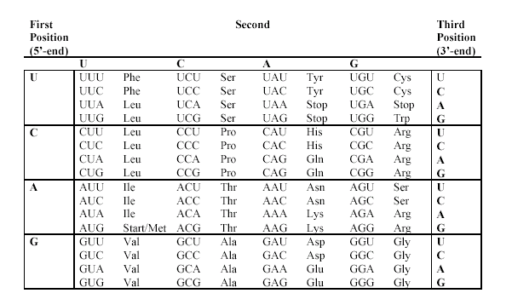

Multiple choice (2 points per question)

1. Secondary structure of proteins, such as the α-helix, is attributed to:
2. Hydrogen bonding between the amide groups on the "backbone."
3. Hydrogen bonding between alcohols on R groups and amides on R groups.
4. Covalent peptide bonds between amino acids.
5. Salt bridges between charged R groups.
6. Hydrophobic attractions of non-polar R groups.
7. The enzyme catalase increases the rate at which hydrogen peroxide is broken down into water and oxygen gas. Catalase works by
8. Increasing the amount of energy released in the reaction.
9. Lowering the activation energy of the reaction.
10. Decreasing how much product was formed during the reaction.
11. Supplying energy to speed up the reaction.
12. Changing the shape of the active site.
13. The purine bases are
14. 6 membered ring systems containing 2 ring nitrogens.
15. 6 membered ring systems containing 4 ring nitrogens.
16. Fused 5 and 6 membered ring systems containing 2 nitrogens.
17. Fused 5 and 6 membered ring systems containing 4 ring nitrogens.
18. None of the above

|  |  |  |  |  |  |  |  |
| --- | --- | --- | --- | --- | --- | --- | --- |
| 1. Consider these two equations:  |  |  | | --- | --- | |  |  | | **(1) Fructose 6-phosphate + HPO42–  Fructose 1,6-bisphosphate + H2O** |  | | **(2) ATP + H2O  ADP + HPO42–** |  |   Which is the final equation for the coupled reaction? | |
| 1. Fructose 1,6-bisphosphate + H2O  Fructose 6-phosphate + HPO42– | |
| 1. ADP + Fructose 1,6-bisphosphate  ATP + Fructose 6-phosphate | |
| 1. ATP + H2O  ADP + HPO42– | |
| 1. ADP + Fructose 6-phosphate  ATP + Fructose 1,6-bisphosphate | |
| 1. ATP + Fructose 6-phosphate  ADP + Fructose 1,6-bisphosphate | |

1. The statement “Enzymes are highly specific” means that certain
2. Enzymes are found in certain cells.
3. Reactions involving certain substrates are catalyzed by certain enzymes.
4. Enzymes require certain concentrations of substrates.
5. Reactions with certain activation energies are catalyzed by certain enzymes.
6. Concentrations of substrates work with certain enzymes.
7. The backbone of a nucleic acid molecule consists of
8. Alternating nitrogen bases and phosphate groups linked by amide bonds and strengthened by hydrogen bonds.
9. Alternating sugar and nitrogen base groups linked by amide bonds.
10. Sugar molecules bonded from the #3 carbon of one molecule to the #5 carbon of the other by glycosidic linkages.
11. Complementary bases joined by hydrogen bonds.
12. Alternating sugar and phosphate groups linked by phosphate ester bonds
13. NAD+ participates in reactions that produce

|  |  |  |
| --- | --- | --- |
| 1. ADP from ATP. | 1. A CH2 group. | 1. A C—C bond. |
| 1. A C=O bond. | 1. Phosphorylation |  |

1. The anti-codon loop involved in translation is found in:

|  |  |  |
| --- | --- | --- |
| 1. the transcribed strand of DNA | 1. the introns of RNA | 1. the exons of RNA |
| 1. transfer RNA | 1. heterogeneous nuclear RNA |  |

1. Allosteric inhibitors act by
2. Decreasing the amount of enzyme molecules.
3. Increasing the amount of enzyme molecules.
4. Decreasing the amount of the inactive form of the enzyme.
5. Decreasing the amount of the active form of the enzyme.
6. Increasing the amounts of substrate.
7. Enzymes are highly sensitive to pH and temperature because
8. Changes in the environment raise their activation energy.
9. Changes in temperature and pH readily break their hydrogen bonds.
10. Of their three-dimensional structure and side chains.
11. At extreme temperatures and pH levels, coenzymes add chemical groups to the substrate.
12. Extremes of temperature and pH level change the ionization rate.
13. A kinase is an enzyme that:
14. Adds water to a double bond.
15. Uses FADH2 to change the oxidation state of the substrate.
16. uses ATP to add a phosphate group to the substrate
17. removes phosphate groups off of substrates
18. none of the above
19. Some enzymes require small organic molecule, such as B vitamins, in order to have full activity. This component is called a:

|  |  |  |
| --- | --- | --- |
| 1. cofactor | 1. coenzyme | 1. regulator |
| 1. substrate | 1. donor groups |  |

1. Put the following translation events in order:
2. elongation of the polypeptide
3. base pairing of methionine-tRNA to AUG of the mRNA
4. the larger ribosomal subunit binds to smaller ribosomal subunits
5. peptide bonding between the first two amino acids
6. the small subunit of the ribosome recognizes and attaches to mRNA

|  |  |  |
| --- | --- | --- |
| 1. i, ii, iii, iv, v | 1. v, iv, iii, ii, i | 1. v, iii, ii, i, iv |
| 1. v, ii, iv, i, iii | 1. v, ii, iii, iv, i |  |

1. Which of the following correctly describes citrate and isocitrate?
2. Citrate is a tertiary alcohol, but isocitrate is a secondary alcohol
3. Citrate is a secondary alcohol, but isocitrate is a tertiary alcohol
4. They are both primary alcohols
5. They are both secondary alcohols
6. They are both tertiary alcohols
7. Which of the following is correct about describing the induced fit model of an enzyme. Substrates fit into the active site:
8. Because as the substrate and enzyme bind they both change shape to induce a better fit
9. By changing their size and shape to match those of the active site
10. By changing the size and shape of the enzyme
11. Because both are exactly the same size and shape
12. None of the above
13. Enzymes are comprised of:

|  |  |  |
| --- | --- | --- |
| 1. Proteins | 1. Triacylglycerols | 1. Fatty acids |
| 1. Carbohydrates | 1. None of the above |  |

1. All of the statements about RNA are correct EXCEPT:
2. RNA can exist in three forms: rRNA, tRNA, and mRNA.
3. RNA does not contain thymine.
4. RNA molecules are smaller than DNA molecules, but form double helices like DNA.
5. Transfer RNA delivers amino acids to the protein chain as it is being manufactured.

All the statements are correct

1. In the reaction in which succinate is converted to fumarate in the citric acid cycle, succinate undergoes a(n):

|  |  |  |
| --- | --- | --- |
| 1. isomerization | 1. hydration | 1. oxidation |
| 1. oxidative decarboxylation | 1. none of the above |  |

1. The substrate may be held in the active site of the enzyme (as the enzyme substrate complex) by

|  |  |  |
| --- | --- | --- |
| a) Ionic attraction | b) Hydrogen bonding | c). Hydrophobic attraction |
| d) All of them | e) None of them |  |

1. RNA splicing refers to
2. Rejoining of broken mRNA transcripts
3. Removal of introns and rejoining of exon sequences in mRNA
4. Covalently attaching more than two RNA molecules into a star pattern
5. Changing one base to another in the maturation of mRNA
6. none of the above
7. The products of glycolysis important in metabolism are

|  |  |  |
| --- | --- | --- |
| 1. CO2and H2O. | 1. acetyl-SCoA and ATP | 1. CO2, ATP, and NADH |
| 1. pyruvate, ATP, and NADH | 1. pyruvate, ADP, and NAD+ |  |



1. Examine the following structures A and B then

choose the best description:

1. Structure A is a dinucleotide for RNA and

Structure B is a dinucleotide for DNA

**b.** Both A and B are DNA dinucleotides

**c.** Both A and B are RNA dinucleotides

**d.** none of the above

1. What substance is produced by the oxidation of pyruvate and feeds into the citric acid cycle

|  |  |  |
| --- | --- | --- |
| 1. oxaloacetate | 1. glucose | 1. Acetyl CoA |
| 1. CO2 | 1. O2 |  |

1. A nucleotide is composed of a ________ with a ________ added to it.

|  |  |
| --- | --- |
| 1. nucleoside; nitrogen base | 1. phosphate group; nitrogen base |
| 1. nucleoside; phosphate group | 1. pentose; nitrogen base |
| 1. pentose; phosphate group |  |

1. Which term most precisely describes the cellular process of breaking down large molecules into smaller ones?

|  |  |  |
| --- | --- | --- |
| 1. Catalysis | 1. metabolism | 1. anabolism |
| 1. dehydration | 1. catabolism |  |

1. All of the following statements concerning digestion are correct except
2. The major physical processes in digestion are mixing, softening and grinding of food.
3. Different foods are digested by different enzymes.
4. The major chemical reaction in digestion is enzyme-catalyzed hydrolysis of large molecules.
5. Digestion can be considered a catabolic process in which bulk food is broken down into individual small molecules.
6. Digestion begins in the stomach and is completed in the large intestine.

Next 5 questions, refer to the following answer choices for the listed descriptions:

|  |  |  |
| --- | --- | --- |
| 1. Primary protein structure | 1. Secondary protein structure | 1. Tertiary protein structure |
| 1. Quaternary protein structure | 1. All of the above |  |

1. Three-dimensional arrangement of every atom in a protein C
2. Sequence of amino acids A
3. Interaction of protein subunits D
4. Arrangement of protein chains into patterns B
5. Is not affected by denaturation A

Problems

1. (6 points) Please draw structure of Ala as a zwitterions and how will it look below and above pI.

|  |  |  |
| --- | --- | --- |
|  |  |  |
| Zwitterion | Below pI | Above pI |

1. (8 points) Draw the structure of Ala-Gly **dipeptide at biological pH**, showing the peptide linkage with an arrow. (label C-terminus, N-terminus)



1. (8 points) Explain the following: using a drawing to illustration
2. Illustrate how an enzyme normally works

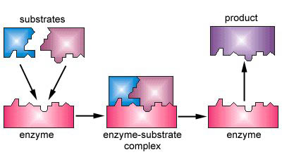

1. Illustrate how an enzyme works with a competitive inhibitor

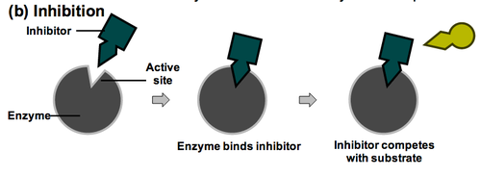

1. Explain how competitive inhibition can be reversed

Because the competitive inhibitor comes on and off the enzyme, and is competing with the substrate for the active site, the inhibition can be reversed by increasing amount of substrate

1. (8 points) First Transcribe from DNA, then translate the resulting mRNA (assume no introns):

DNA: 3’- TAC AAA ATA CAT ATT-5’

mRNA: 5’-**AUG**UUUUAUGUAUAA-3’

protein: f-met-phe-tyr-val

1. (9 points) List the three major types of RNA and their functions.

1. Messenger RNA (mRNA) carries the information that specifies a protein.

2. Ribosomal RNA (rRNA) combines with proteins to form a ribosome, the physical location of protein synthesis.

3. Transfer RNA (tRNA): molecules are “connectors” that bind mRNA codons at one end and specific amino acids at the other. Their role is to carry each amino acid to the ribosome at the correct spot along the mRNA molecule.

1. (4 points) Circle the high energy molecule within the pair

FAD or FADH2

NADH or NAD+

ADP or ATP

CoA or AcCoA

**Citric Acid Cycle**

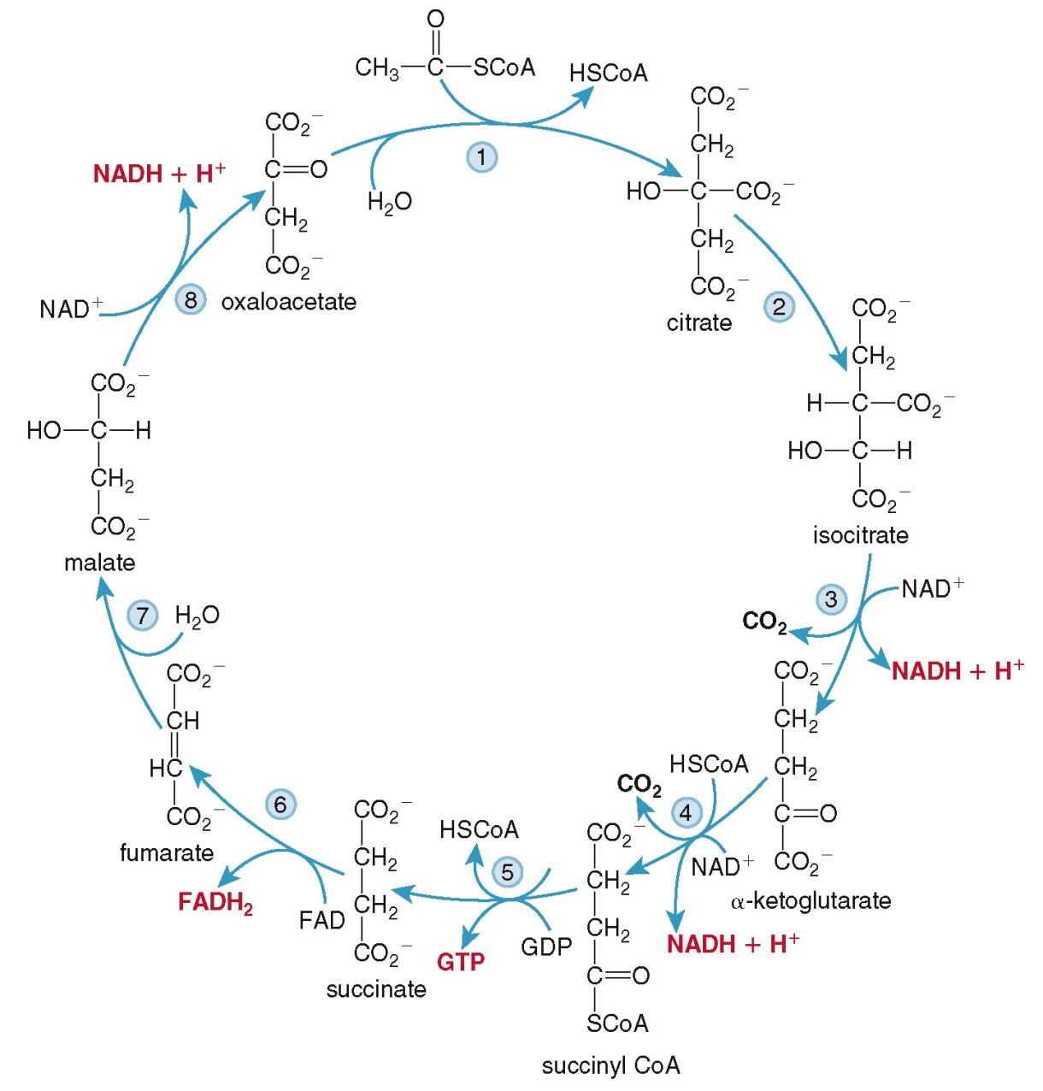

**Glycolysis**

